Single Node Installation
- Take an Ubuntu 14.04 EC2 instance.
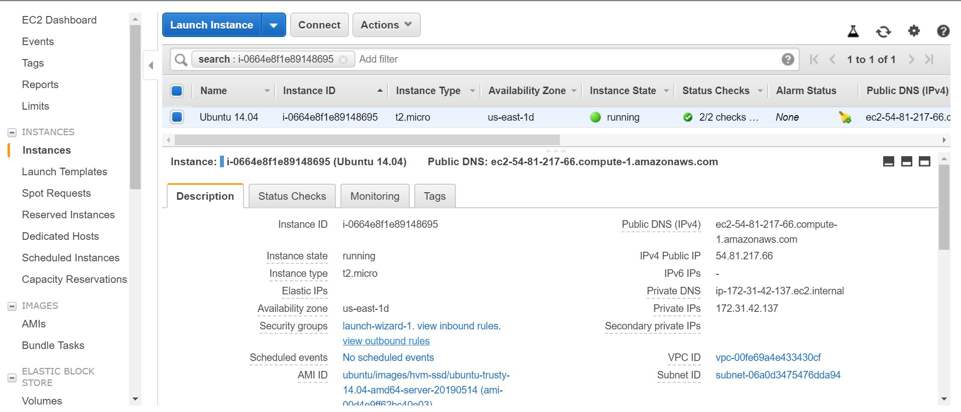

- Connect to this Ubuntu machine using public IP
- In Mac/ Ubuntu using terminal
- In Windows using Putty
- While using Putty we have to import our key to the server using pscp in Powershell/ WinScp.
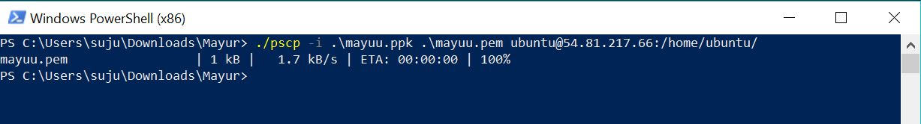
- Chmod 400 mayuu.pem
- Connect to the machine
ssh -i "mayuu.pem" ubuntu@ec2-54-81-217-66.compute-1.amazonaws.com
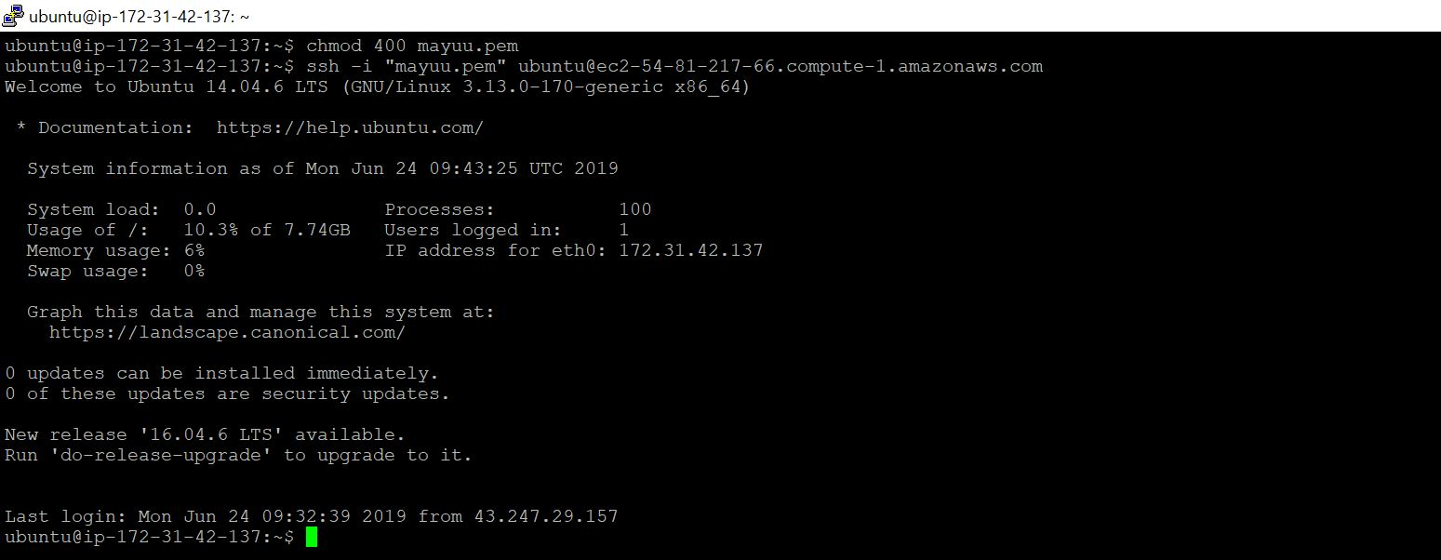
Now we are done connecting, now we have to install a cluster on single node.
- sudo apt-get update
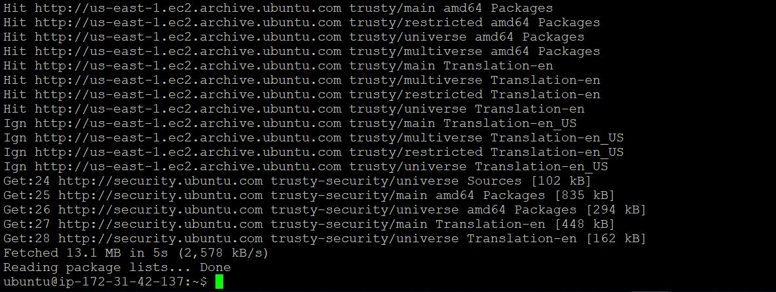
- Downloading and installing java (Hadoop requires a working Java 1.6+)
sudo apt-get install openjdk-7-jdk -y

- Downloading Hadoop

wget
https://archive.apache.org/dist/hadoop/common/hadoop-1.2.1/hadoop-1.2.1.tar.gz

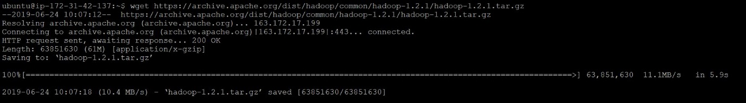

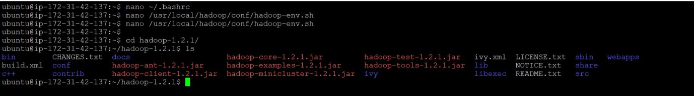

tar -xzvf hadoop-1.2.1.tar.gz

sudo mv hadoop-1.2.1 /usr/local/Hadoop

- Configuring bashrc linux env setup
nano ~/.bashrc
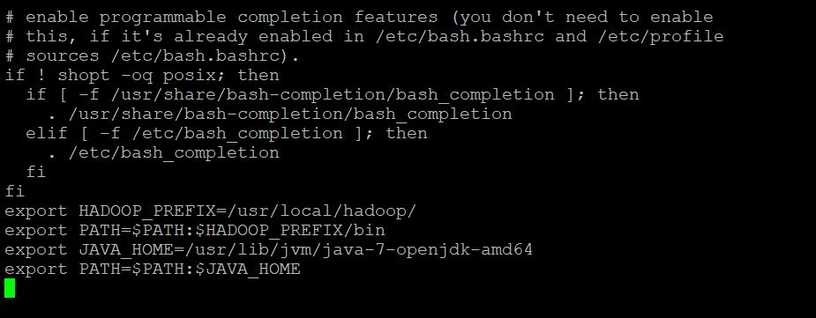

- Setting hadoop env
nano /usr/local/hadoop/conf/hadoop-env.sh
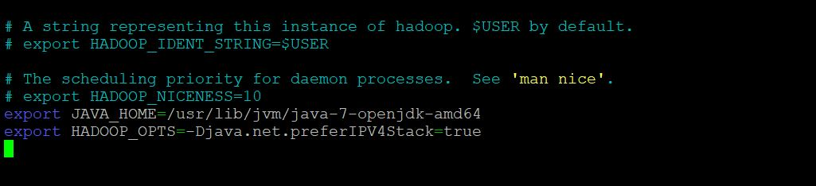
- Configuring xml's

- Configuring core-site.xml
nano /usr/local/hadoop/conf/core-site.xml
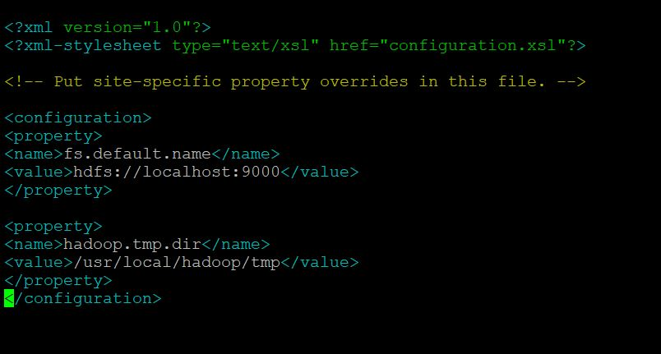

- Configuring hdfs-site.xml
nano /usr/local/hadoop/conf/hdfs-site.xml
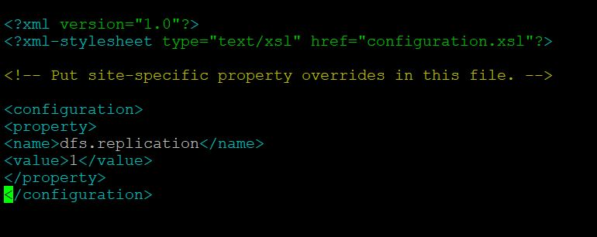

- Configuring mapred-site.xml
nano /usr/local/hadoop/conf/mapred-site.xml]

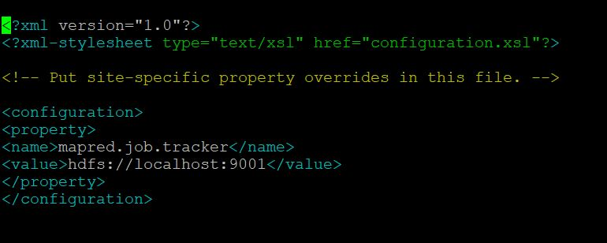

- Making tmp dir
mkdir /usr/local/hadoop/tmp

- **Exec bash**
exec bash
- We have to create rsa-key pair to communicate to localhost
ssh-keygen
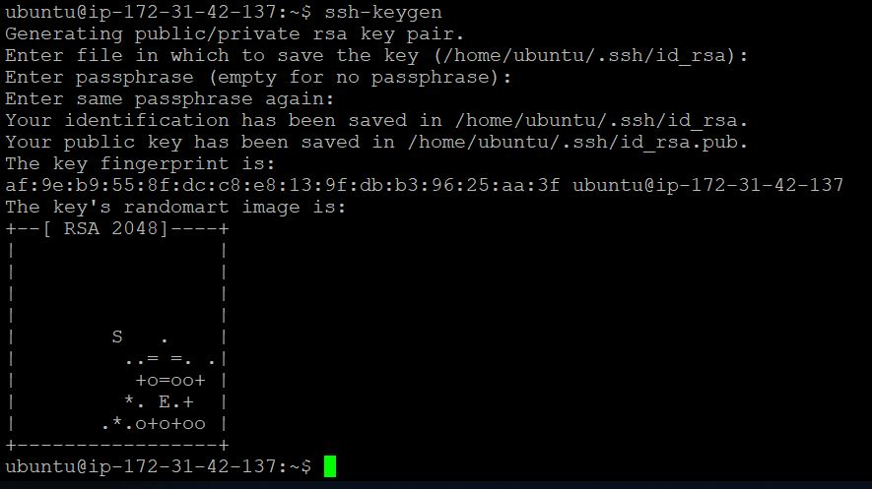
>> Authorisation
cat ~/.ssh/id_rsa.pub >> ~/.ssh/authorized_keys

- Configuring DNS address for local
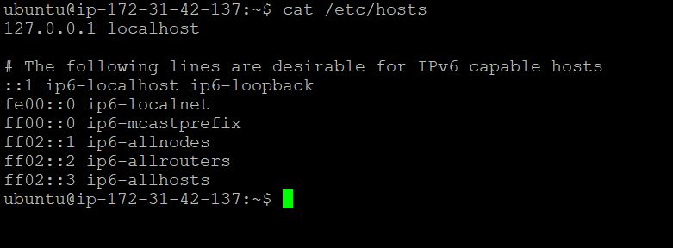

- ssh localhost
connecting to the localhost

- Formatting hadoop namenode

hadoop namenode -format
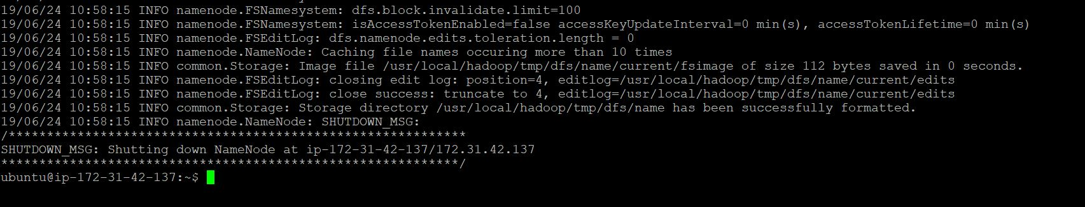

- Starting physical daemons
start-dfs.sh

- Starting logical daemons
Start-mapred.sh

- jps
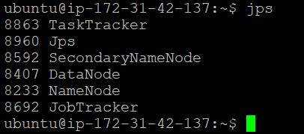

- Accessing Namenode using Web UI
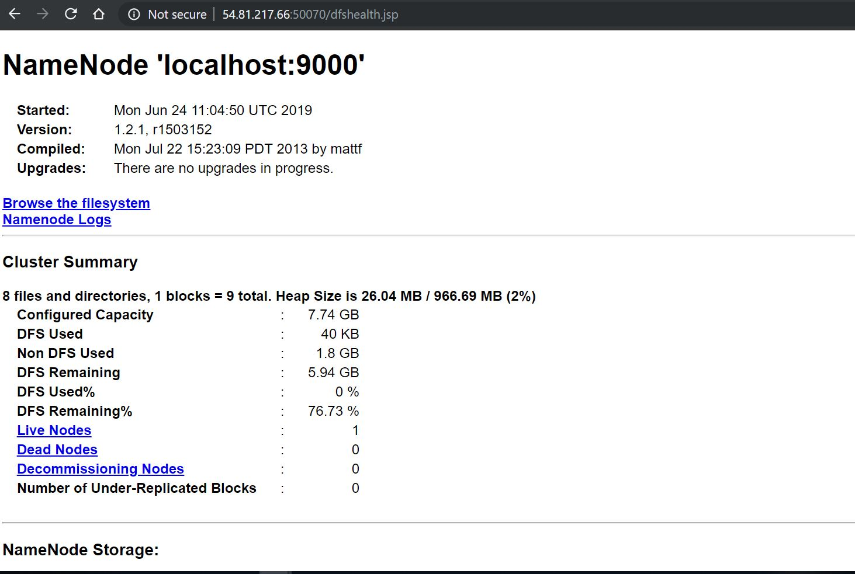

- Now creating a file & uploading data on the cluster.
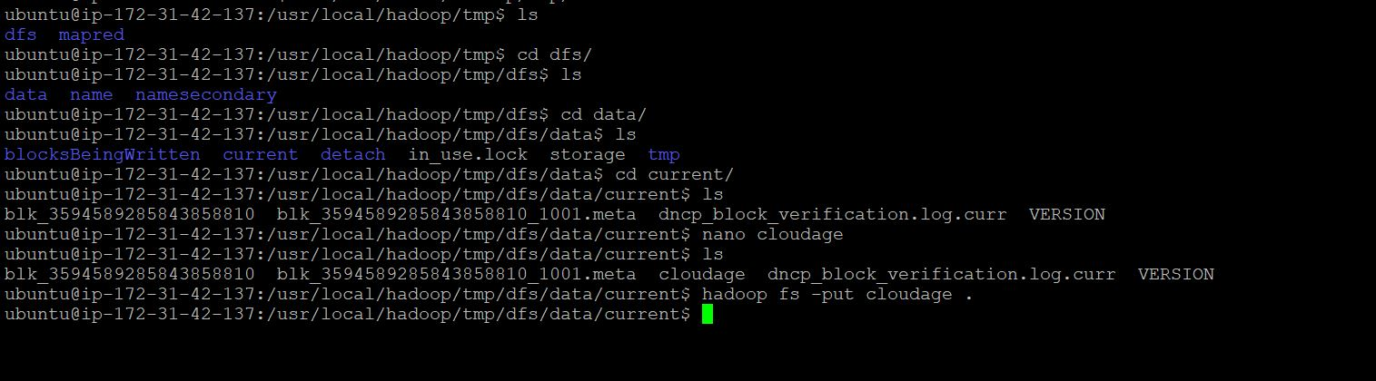

hadoop fs -put cloudage .
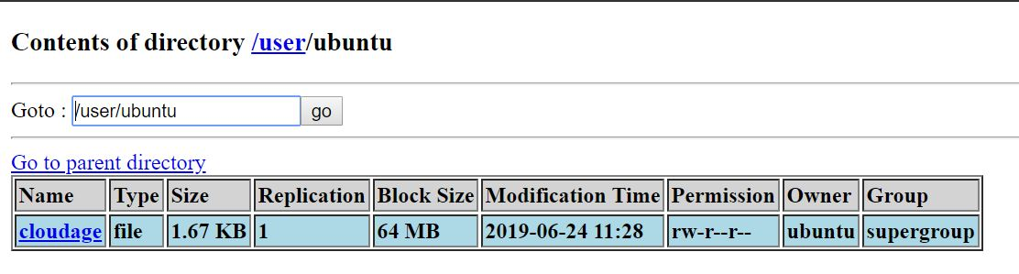
- Benchmarking
Running a pi Job
